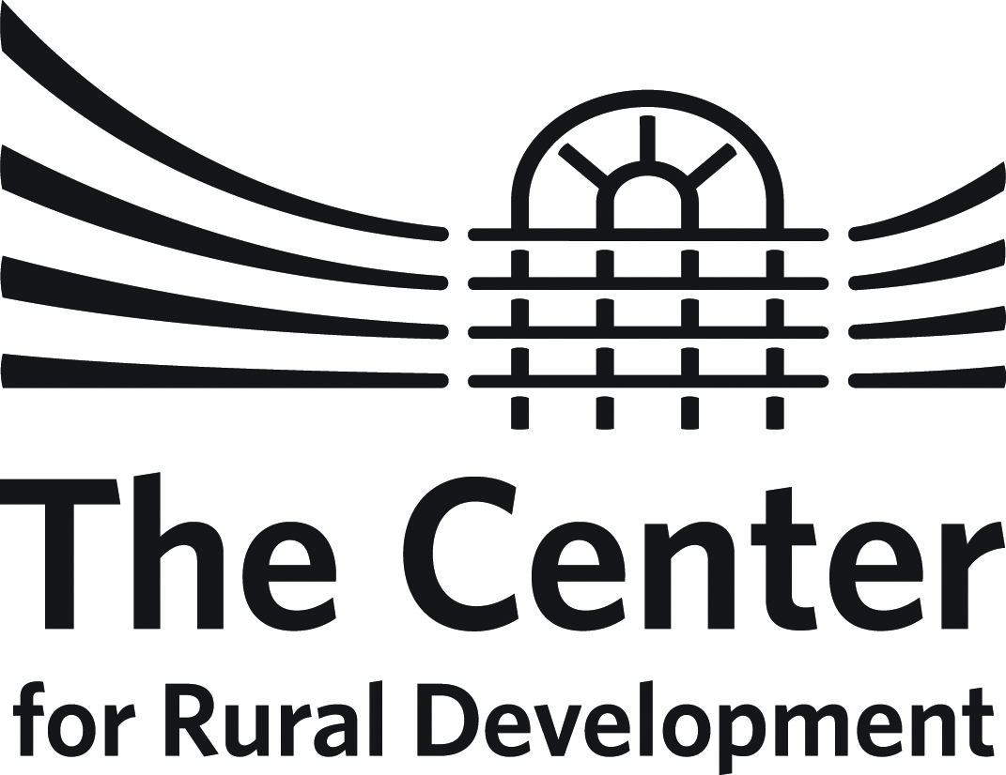

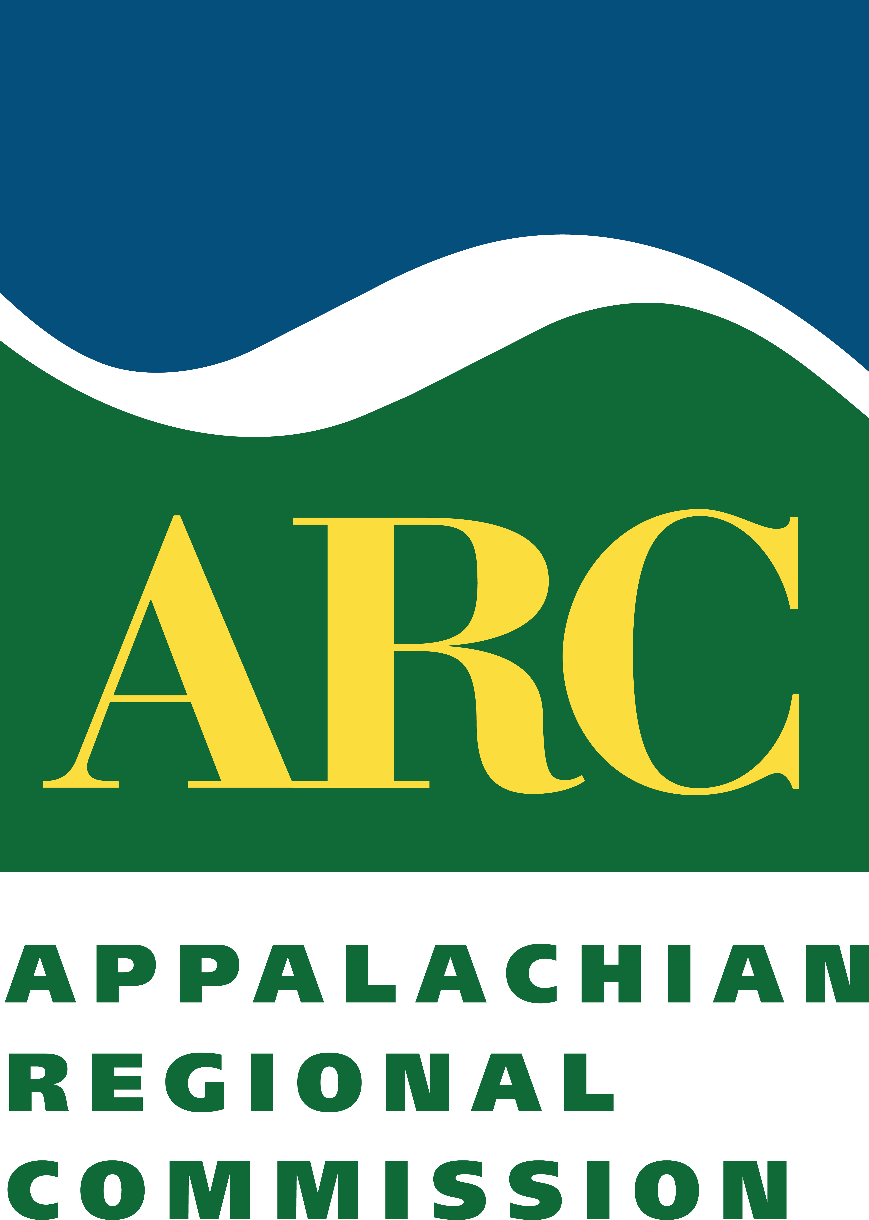

KENTUCKY ARC FLEX-E-GRANT PROGRAM
Guidelines for Flex-E-Grant APPLICATION
DeadLine for Application: October 20, 2020

Summary
The Flex-E-Grant (FEG) Program, designed by the Appalachian Regional Commission (ARC), provides strategic investments in projects that build community capacity to mobilize local resources, gain leadership experience, and strengthen community institutions and networks.

The Center for Rural Development administers program funds in partnership with the Kentucky Department for Local Government (DLG) and the Appalachian Regional Commission.

Grants are subject to approval for up to $7,500, require a 20 percent match of total project costs, and are to be completed within a 4-month timeframe. Flex-E-Grant funds are made available on a reimbursement basis only.

The FEG program was generated from the ARC's initiative to enhance assistance to distressed counties, and each approved project must demonstrate beneficiaries in a distressed county.

Competitive project proposals will advance the strategic investment goals of ARC’s 2016-2020 Strategic Plan (Investing in Appalachia’s Future: The Appalachian Regional Commission’s Five-Year Strategic Plan for Capitalizing on Appalachia’s Opportunities—2016-2020 see www.arc.gov). The Five (5) ARC strategic investment goals include: economic opportunities, ready workforce, critical infrastructure, natural and cultural assets, and leadership and community capacity. At all levels, ARC is committed to investing organizational and financial resources in proposals that are designed to be strategic, collaborative, impactful, and sustainable.

Although the primary intent of the program is to support efforts that help develop local capacity, eligible activities may also include collaboration among communities in support of existing and emerging regional development efforts.

Eligibility
Counties within The Center’s service area that were designated as economically distressed for fiscal year of 2018 are eligible to apply for the 2020 KY-ARC Flex-E-Grant Program. Competitive planning grants are available for non-profit entities or units of government interested in implementing planning projects that build community capacity.

Eligible Counties Include:
Adair, Bath, Bell, Breathitt, Carter, Casey, Clay, Clinton, Cumberland, Elliott, Estill, Floyd, Harlan, Jackson, Johnson, Knott, Knox, Lawrence, Lee, Leslie, Letcher, Lincoln, Magoffin, Martin, McCreary, Menifee, Morgan, Owsley, Perry, Pike, Rockcastle, Russell, Wayne, Whitley, and Wolfe

If approved, grantees will be responsible for administering, monitoring, and reporting the results of their program.

Grant Components
This cycle of Flex-E-Grants will focus on planning activities; particularly those that consist of pandemic recovery and/or preparedness. This cycle may be awarded for a variety of capacity building planning projects, which might include but are not limited to:

- Strategic planning and management processes for communities or non-profit groups;
- Addition of pandemic planning addendum to an existing community-based strategic plan;
- Training related to pandemic recovery and preparedness for citizen leaders, local officials, management and staff from non-profit community agencies as well as boards or commissions;
- Support for initiatives that enhance leadership, planning and management capacity for distressed counties, such as initiatives to increase collaboration, interaction and access to information;
- Use of professional services to assess a project's feasibility, to offer consulting advice on a strategy, to support application development, etc.

The Center, ARC and DLG seek to fund proposals that strengthen economic growth and development in Kentucky’s distressed Appalachian counties. Proposals that build capacity through the promotion, support and advancement of economic development will have priority.

Flex-E-Grant funds may not be used for equipment purchase, construction costs, or administrative expenses or indirect costs.

Application and Selection Processes
All applications should follow established guidelines and be submitted on the supplied application form.

All proposals will be reviewed by a review committee. The committee will not consider applications that do not address permissible FEG activities or do not serve distressed counties.

The Flex-E-Grant program serves to improve economic conditions within distressed counties by developing local and regional leadership, supporting long-term visioning and strategic planning, and laying foundations for more intensive investments and interventions.

Types of projects receiving emphasis will:
- include quantified (and reasonable) outputs and outcomes that demonstrate community capacity building;
- emphasize broad community participation and involvement in the planning and implementation process;
- promote collaboration among community groups, resulting in establishing coalitions, networks, and partnerships that may extend beyond the community;
- demonstrate how individuals will develop the skills and capacities to strengthen community networks and effectively address community issues;
- demonstrate how proposed activities help the community prepare for and move toward economic success; and
- demonstrate potential to inform or advance regional planning or development efforts, such as SOAR, or other regional capacity building initiatives.

Criteria for assessing applications include:
- The relevance of the application to the overall intent and purpose of the Kentucky Flex-E-Grant program.
- Applicant and/or provider’s experience with similar successful projects in ARC Distressed Counties.
- Reasonableness of cost and overall budget. Matching funds must be available and committed.
- Applicant and/or provider’s capacity to complete the project within four months.
- Potential of the project to increase local or regional capacity for community and economic development by:
- increasing the skills, knowledge, and abilities of individuals, organizations, and communities to more effectively participate in development efforts;
- enhancing the ability of a local community to strengthen and institutionalize ongoing community improvement efforts;
- identifying and developing a local or regional asset for community development;
- promoting long-term planning and strategic thinking for a community, region, or community/regional organization; and
- expanding or deepening economic development efforts in Appalachian Kentucky through entrepreneurship, business development, a ready workforce and/or worker recovery.
Timetables
Proposals are due by October 20, 2020. Awards will be announced in November 2020.

Proposals may be submitted to The Center for Rural Development.

Digital files are preferred and may be emailed to arc@centertech.com.

If awarded, project activities must conclude within four (4) months of grant award. Financial reconciliation must be completed within 30 days after completion of the project.

Grant Requirements
All selected applicants will be required to fully participate in any formal evaluation process and to attend any mandatory technical assistance workshops or trainings.

Grantees are also required to submit both a mid-term and final report on project activities. These reports may be accompanied by a request for disbursement. To receive reimbursement funds, grantees must file a Request for Disbursement form accompanied by financial documentation relevant to the request. Final payment will be disbursed only after the filing of the final project report.

Contact Information
Should you have any questions about the KY-ARC Flex-E-Grant program, please contact:
Patti Simpson
The Center for Rural Development
psimpson@centertech.com
(606) 677-6110

