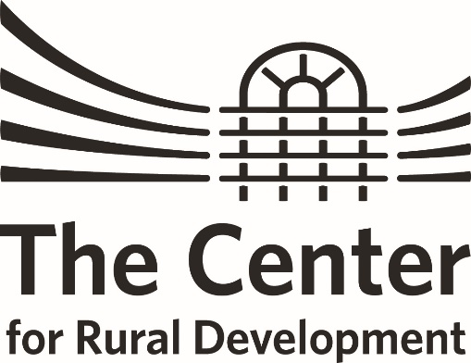
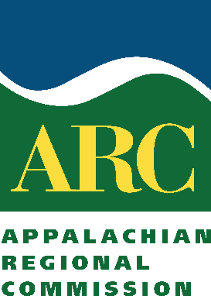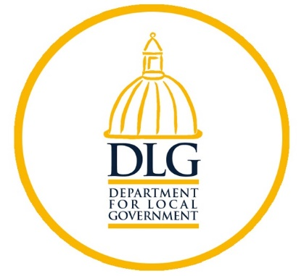
KENTUCKY ARC FLEX-E-GRANT PROGRAM
Flex-E-Grant Proposal Form
DeadLine for Application: October 20, 2020
Please submit the application form, project narrative, and budget worksheet to arc@centertech.com.
I. Applicant Organization

Organization Name:
Staff Contact Name, Title:
Street Address:
City, State Zip:
Email:
Phone Number:
County Represented:

II. Fiscal Agent (if different from applicant) Must be a 501(c)(3) or government agency. Please identify which below.

Name of Fiscal Agent:
Designation: | 501(c)(3) Government Agency
Staff Contact Name, Title:
Street Address:
City, State Zip:
Email:
Phone Number:

III. Project Description

Project Name:
Requested Grant Amount:
Match Amount:
Total Project Budget:
In the box below, please briefly describe your project activities. Define the community issue or challenge the project addresses; briefly describe the goal or purpose of the project; and identify who will be involved in carrying out project activities. See example of a brief project description on page 2.

IV. Project Category / Area of Focus
Please select the category that most closely relates to the project’s primary area of focus.
(Please limit your selection to one category.)

☐ Economic Development – includes strategic planning, regional collaboration, entrepreneurial and business development projects.
☐ Ready Workforce – includes workforce education, retraining, recovery, and health projects.
☐ Natural and Cultural – includes tourism, natural resources and cultural opportunities that strengthen the local or regional economy.
☐ Leadership and Community Capacity – includes leadership development, youth engagement, planning, and training projects.
Top of Form

The Center, ARC and DLG seek to fund proposals that strengthen economic growth, development and recovery in Kentucky’s distressed Appalachian counties during this time of pandemic and post-pandemic. Proposals that build capacity through the promotion, support and advancement of economic development will have priority.

PROPOSAL SECTIONS
Directions: The sections below outline the elements of a Flex-E-Grant proposal. Please use this information to develop a grant proposal as a separate attachment to the proposal cover sheet on Page 1

I. Project Narrative: What activities will this grant fund? (Maximum 2 Pages)
Briefly describe the scope of work for the proposed four-month project. The description should:

- Identify who the project serves. (i.e. at-risk youth, business owners, unemployed residents, etc.)
- Provide a detailed description of the major project activities.
- Describe how these activities address community needs.
- Identify who will carry out the work of the project and what qualifies them to do so.
- Explain how the project benefits the community and builds community capacity.
- Detail how the project aligns with existing community plans or goals. (i.e. How is this project connected to or informed by larger community visions, existing plans, or ongoing community efforts? Please provide background information to demonstrate connection.)
- Explain how the project addresses the interest area you selected in the Project Category / Area of Focus section of this proposal form.
- How will the economic and/or social conditions in your community, county, or region improve as a result of project activities?
- Identify community assets that will be created, developed, or left in place as a direct result of project activities.
A community asset is anything that can be used to improve the quality of community life. Assets can be people, physical structures or places, community services, etc. As examples, projects may contribute to the development of the following assets:
- an increase in leadership skills and the number of individuals taking leadership responsibility in the community (people);
- an economic recovery plan will in place to assist in recovery following pandemic or other catastrophic event.

II. Performance Measures: What results do you expect? How will you measure success? (Maximum 1 Page)
Performance measures help define the goals of your project and determine your success toward achieving those goals. Measures are expressed in terms of outputs and outcomes that can be quantified or counted. Therefore, all outputs and outcomes should have a number associated with them. The project proposal is required to address both outputs and outcomes.
Outputs may measure how many individuals, organizations or communities you expect to participate in or be served by project activities. For example, an applicant may propose hosting a public meeting to get broad input from the community. To quantify this goal, the applicant might ask, “What would qualify as broad input?” or “What can we reasonably consider as an indicator of success?” The resulting OUTPUTS may then become:
- Hold one county-wide summit with 60 people attending and participating in the planning process.
- 8 strategic task forces will be formed during the county-wide summit.
- Project activities will result in the revision of a community strategic plan.

Additional examples of anticipated outputs may include quantifiable products. For example:
- 10 new community partnerships will be created.
- One community assessment will be completed with the assistance of an outside consultant.
- An engineering firm will assist community members with the completion of a feasibility study.

Outcomes measure the anticipated effect that activities will have on individuals, organizations and communities. These measures may be developed in response to the following questions:

- How do you anticipate project activities will build the capacity of individuals, organizations, or your community?
- How do you anticipate economic or social conditions within your community, county, or region might improve as a direct result of planned project activities?

As an example, hosting the public meeting referenced in the sample outputs above will also have some OUTCOMES that represent the impact the meeting will have on participants and the community. These may be:
- A strategic plan will be produced with input from at least 60 different people and a summary of the plan will be distributed to 10,000 local households through being included with a monthly electric bill mailing.
- At the county-wide summit, 60 community residents will assist with the creation of action plans to guide the work of task forces. At least 40 of these community members will commit to serving on a task force.
- 8 community organizations will assign a representative to work on a task force that aligns with the organization’s mission.
- 8 strategic task forces will begin implementation of strategies in the community, with at least 5 community members per task force, resulting in 40 individuals being active in community projects going forward.

III. Project Timeline
Projects must be designed on a 4-month timeline. Please provide a detailed chronological timeline of all proposed project activities from MONTH 1 – MONTH 4.

This timeline should reflect main activities, meetings, events, and deadlines for completion of products and other proposed milestones.

IV. Project Budget (Please Use Form Provided)

Complete the detailed budget form. The Excel budget worksheet includes auto-calculation fields to assist with budget completion and verification of project match.

Also note that ineligible expenses include equipment purchases, construction costs, and the use of Flex-E-Grant funds for a grantee’s administrative expenses (personnel related costs) and indirect costs.

V. Budget Narrative

The budget narrative must accompany the project budget and explain in detail expenditures by line item while also providing rationale for each of the project expenses.

VI. Sustainability and Continuation of Capacity Building Efforts
This section of the proposal should be developed in response to the following questions:

- What assets will this capacity building project leave in place upon completion?
- How will activities be maintained and built upon to serve the community and its needs beyond the project?
- What long-term community plans or goals does this project help advance or accomplish?
- How might this project inform or advance existing or emerging regional planning or development efforts?

VII. Submitting Your Application

Prior to completing the Flex-E-Grant Application, please review the instruction materials and application carefully.

Please use ONLY the forms provided. Many sections are designed to expedite review and evaluation of the application. All applications must be thoroughly completed. Completed applications must be postmarked or emailed no later than October 20, 2020. Awards will be announced in November 2020.

Proposals may be submitted to The Center for Rural Development. Proposals will be considered by a review committee and notified of approval or denial by the then above announcement date.

Digital files are preferred and may be emailed to arc@centertech.com.

Proposals are also accepted by mail at the following address:
The Center for Rural Development
Patti Simpson
2292 South Hwy. 27
Somerset, KY 42501
If awarded, project activities must conclude within four (4) months of grant award. Financial reconciliation must be completed within 30 days after completion of the project.

Should you have any questions while completing this application, please contact:
Patti Simpson
The Center for Rural Development
psimpson@centertech.com
(606) 677-6110

