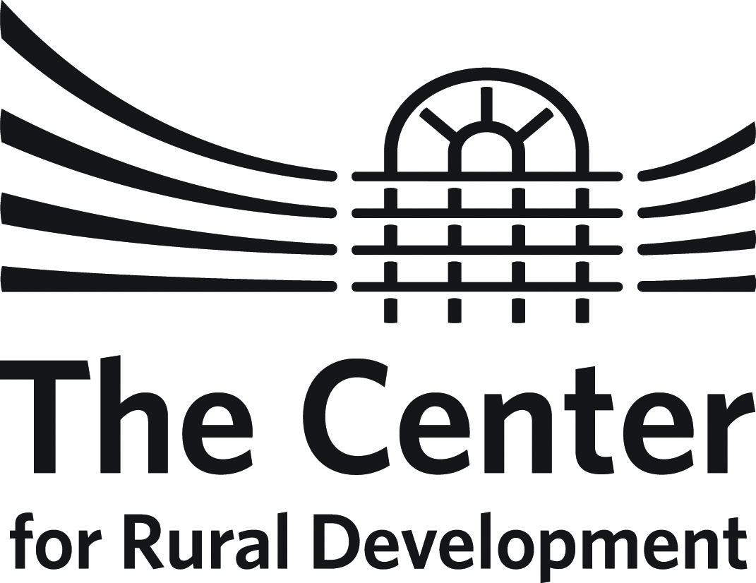

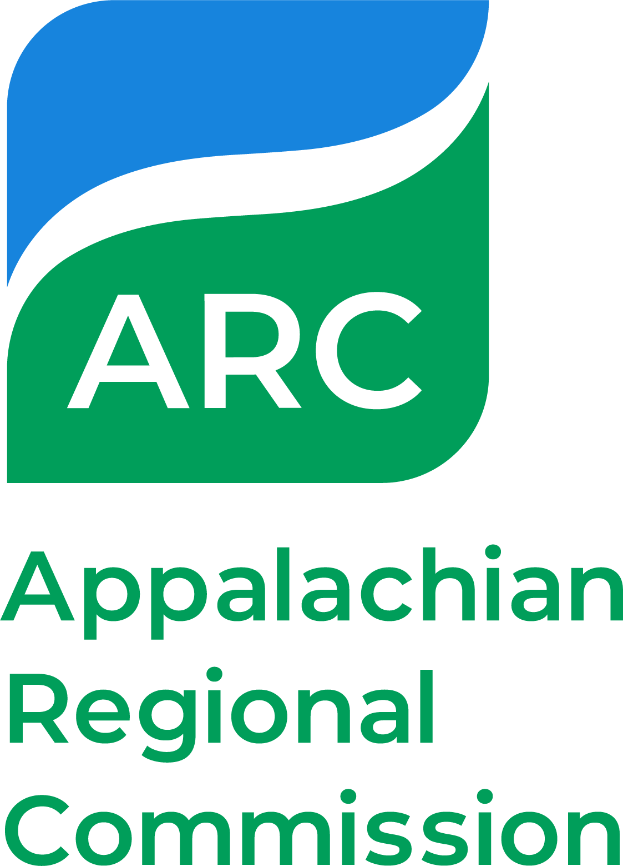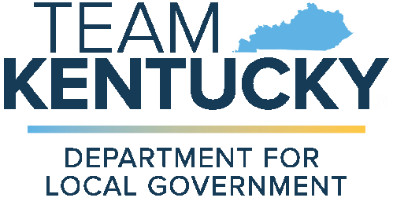

KENTUCKY ARC Mini GRANT PROGRAM
Guidelines for Mini Grant APPLICATION
2024 funding cycle

Summary
The Mini Grant (sometimes referred to as Flex-E-Grant) Program, is accepting proposals from qualified local units of government and non-profit entities for capacity building planning and implementation projects. The Mini Grant program provides strategic investments in projects that build community capacity to mobilize local resources, gain leadership experience, and strengthen community institutions and networks.

The Center for Rural Development administers program funds in partnership with the Kentucky Department for Local Government (DLG) and the Appalachian Regional Commission.

Grants are subject to approval for up to $10,000, require a 20% match of total project costs, and are to be completed within a 6-month timeframe. Mini Grant funds are available on a reimbursement basis only.

Competitive project proposals will advance the strategic investment goals of ARC’s 2022-2026 Strategic Plan (https://www.arc.gov/strategicplan/). The Five (5) ARC strategic investment goals include: Building Appalachian Businesses, Building Appalachia’s Workforce Ecosystem, Building Appalachia’s Infrastructure, Building Regional Culture and Tourism, and Building Community Leaders and Capacity.

Although the primary intent of the program is to support efforts that help develop local capacity, eligible activities may also include collaboration among communities in support of existing and emerging regional development efforts.

Eligibility
Counties within The Center’s service area that are designated as economically distressed by ARC for fiscal year of 2023 are eligible to apply for the 2024 Mini-Grant Program. Competitive planning grants are available for non-profit entities or units of government interested in implementing planning projects that build community capacity.

Eligible Counties Include:
Bath, Bell, Breathitt, Carter, Casey, Clay, Clinton, Elliott, Estill, Floyd, Harlan, Jackson, Johnson, Knott, Knox, Lawrence, Lee, Leslie, Letcher, Magoffin, Martin, McCreary, Menifee, Metcalfe, Morgan, Owsley, Perry, Pike, Rockcastle, Rowan, Wayne, Whitley, and Wolfe

If approved, grantees will be responsible for administering, monitoring, and reporting the results of their program.

Grant Components
Mini Grants may be awarded for a variety of capacity building projects, which might include but are not limited to:

- Strategic planning and management processes for communities or non-profit groups.
- Implementation of projects from a community-based strategic plan.
- Training for citizen leaders, local officials, management, and staff from non-profit community agencies as well as boards or commissions.
- Support for initiatives that enhance leadership, planning and management capacity for distressed counties, such as initiatives to increase collaboration, interaction, and access to information.
- Use of professional services to assess a project's feasibility, to offer consulting advice on a strategy, to support application development, etc.

The Center, ARC and DLG seek to fund proposals that strengthen economic growth and development in Kentucky’s distressed Appalachian counties. Proposals that build capacity through the promotion, support and advancement of economic development will have priority.

Mini Grant funds may not be used for equipment purchase, construction costs, or administrative expenses or indirect costs.

Application and Selection Processes
All applications should follow established guidelines and be submitted on the supplied application form.

All proposals will be reviewed by a review committee. The committee will not consider applications that do not address permissible activities or do not serve distressed counties.

The Mini Grant program serves to improve economic conditions within distressed counties by developing local and regional leadership, supporting long-term visioning and strategic planning, and laying foundations for more intensive investments and interventions.

Types of projects receiving emphasis will:
- include quantified (and reasonable) outputs and outcomes that demonstrate community capacity building;
- emphasize broad community participation and involvement in the planning and implementation process;
- promote collaboration among community groups, resulting in expanded networks and partnerships that may extend beyond the community;
- demonstrate how individuals will develop the skills and capacities to strengthen community networks and effectively address community issues;
- demonstrate how proposed activities help the community prepare for and move toward economic success; and
- demonstrate potential to advance regional planning and/or development efforts to build the capacity of the region.

Criteria for assessing applications include:
- The relevance of the application to the overall intent and purpose of the mini-grant program.
- Applicant and/or provider’s experience with similar successful projects in ARC Distressed Counties.
- Reasonable cost and overall budget. Matching funds must be available and committed.
- Applicant and/or provider’s capacity to complete the project within six months.
- Equity and need.
- Potential of the project to increase local or regional capacity for community and economic development by:
- Building Community Leaders and Capacity – includes leadership development, youth engagement, planning, and training projects. Building Community Leaders and Capacity – includes leadership development, youth engagement, planning, and training projects.Building Community Leaders and Capacity – includes leadership development, youth engagement, planning, and training projects.
☒

- Building Appalachian Businesses - includes strategic planning, regional collaboration, entrepreneurial and business development projects.
- Building Appalachia’s Workforce - includes workforce education, retraining, recovery, and health projects.
- Building Appalachia’s Infrastructure - includes planning projects that enhance the infrastructure to help citizen’s live and work in the region.
- Building Regional Culture and Tourism - includes projects that help preserve the region’s local, cultural heritage, and natural assets.
- Building Community Leaders and Capacity– includes leadership development, youth engagement, planning, and training projects.
Timetable
Proposals are due December 6, 2023.

Proposals should be submitted electronically to The Center for Rural Development.

Digital files are preferred and may be emailed to arc@centertech.com.

If awarded, project activities must conclude within six (6) months of grant award. Financial reconciliation must be completed within 30 days after completion of the project.

Grant Requirements
Grantees are also required to submit both a mid-term and final report on project activities. These reports may be accompanied by a request for disbursement. To receive reimbursement funds, grantees must file a Request for Disbursement form accompanied by financial documentation relevant to the request. Final payment will be disbursed only after the filing of the final project report.

Proposal directions: Below are the required elements of the Mini-Grant proposal. Please use this information to develop a grant proposal using the 2024 Proposal Form - Template.

*Please note that The Center and all Mini-Grant Awardees are required to adhere to 2 CFR PART 200 regulations.

I. Project Narrative: What activities will this grant fund? (Maximum 2 Pages)
Briefly describe the scope of work for the proposed four-month project. The description should:
- Identify who the project serves. (i.e., at-risk youth, business owners, unemployed residents, etc.)
- Provide a detailed description of the major project activities.
- Describe how these activities address community needs.
- Identify who will carry out the work of the project and what qualifies them to do so.
- Explain how the project benefits the community and builds community capacity.
- Detail how the project aligns with existing community plans or goals. (i.e., How is this project connected to or informed by larger community visions, existing plans, or ongoing community efforts? Please provide background information to demonstrate connection.)
- Explain how the project addresses the interest area you selected in the Project Category / Area of Focus section of this proposal form.
- How will the economic and/or social conditions in your community, county, or region improve as a result of the project activities?
- Identify community assets that will be created, developed, or left in place as a direct result of project activities.
A community asset is anything that can be used to improve the quality of community life. Assets can be people, physical structures or places, community services, etc. As examples, projects may contribute to the development of the following assets:
- an increase in leadership skills and the number of individuals taking leadership responsibility in the community (people).
- an economic recovery plan will in place to assist in recovery following pandemic or other catastrophic event.

II. Performance Measures: What results do you expect? How will you measure success? (Maximum 1 Page)
Performance measures help define the goals of your project and determine your success toward achieving those goals. Measures should be expressed in terms of outputs and outcomes that can be quantified or counted. Therefore, all outputs and outcomes should have a number associated with them. The project proposal should address both outputs and outcomes.

Outputs may measure how many individuals, organizations, or communities you expect to participate in or be served by project activities. For example, an applicant may propose hosting a public meeting to get broad input from the community. To quantify this goal, the applicant might ask, “What would qualify as broad input?” or “What can we reasonably consider as an indicator of success?” The resulting OUTPUTS may then become:
- Hold one county-wide summit with sixty people attending and participating in the planning process.
- Eight strategic task forces will be formed during the county-wide summit.
- Project activities will result in the revision of a community strategic plan.

Additional examples of anticipated outputs may include quantifiable products. For example:
- Ten new community partnerships will be created.
- One community assessment will be completed with the assistance of an outside consultant.
- An engineering firm will assist community members with the completion of a feasibility study.

Outcomes measure the anticipated effect that activities will have on individuals, organizations, and communities. These measures may be developed in response to the following questions:
- How do you anticipate project activities will build the capacity of individuals, organizations, or your community?
- How do you anticipate economic or social conditions within your community, county, or region might improve as a direct result of planned project activities?

As an example, hosting the public meeting referenced in the sample outputs above will also have some OUTCOMES that represent the impact the meeting will have on participants and the community. These may be:
- A strategic plan will be produced with input from at least sixty different people and a summary of the plan will be distributed to 10,000 local households through being included with a monthly electric bill mailing.
- At the county-wide summit, sixty community residents will assist with the creation of action plans to guide the work of task forces. At least forty of these community members will commit to serving on a task force.
- Eight community organizations will assign a representative to work on a task force that aligns with the organization’s mission.
- Eight strategic task forces will begin implementation of strategies in the community, with at least five community members per task force, resulting in forty individuals being active in community projects going forward.

III. Project Timeline
Projects must be on a 6-month timeline. Please provide a detailed chronological timeline of all proposed project activities from MONTH 1 – MONTH 6.

This timeline should reflect main activities, meetings, events, and deadlines for completion of products and other proposed milestones.

IV. Project Budget (Please Use Form Provided)
Complete the detailed budget form. The Excel budget worksheet includes auto-calculation fields to assist with budget completion and verification of project match.

Also note that ineligible expenses include equipment purchases, construction costs, and the use of Mini Grant funds for a grantee’s administrative expenses (personnel related costs) and indirect costs.

V. Budget Narrative
The budget narrative must accompany the project budget and explain in detail expenditures by line item while also providing rationale for each of the project expenses.
VI. Sustainability and Continuation of Capacity Building Efforts
This section of the proposal should be developed in response to the following questions:
- What assets will this capacity building project leave in place upon completion?
- How will activities be maintained and built upon to serve the community and its needs beyond the project?
- What long-term community plans or goals does this project help advance or accomplish?
- How might this project inform or advance existing or emerging regional planning or development efforts?

VII. Submitting Your Application
Prior to completing the Mini-Grant Application, please review the instruction materials and application carefully.

Please use ONLY the forms provided. Sections are designed to expedite review and evaluation of the application.

Submit proposals digitally to The Center for Rural Development.

Please submit proposals by email to arc@centertech.com.

If awarded, project activities must conclude within six (6) months of grant award. Financial reconciliation must be complete within 30 days after completion of the project.

Should you have any questions while completing this proposal, please contact:
Patti Simpson
The Center for Rural Development
psimpson@centertech.com
(606) 677-6110

