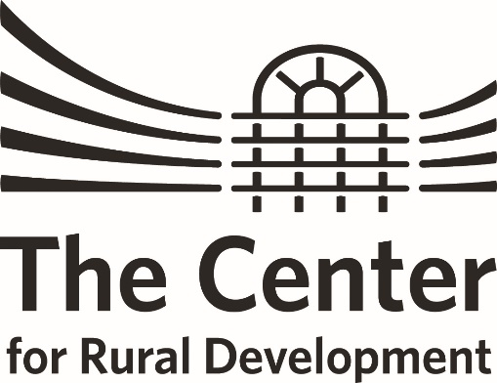
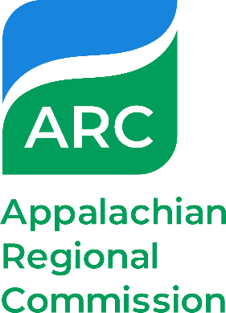
KENTUCKY ARC FLEX-E-GRANT PROGRAM
Mini Grant Proposal Form
2024 Funding cycle
Proposal Due date: December 6, 2023
Please submit the application form, project narrative, and budget worksheet to arc@centertech.com.

*Please note that The Center and all Mini-Grant Awardees are required to adhere to 2 CFR PART 200 regulations.
I. Applicant Organization

Organization Name:
Staff Contact Name, Title:
Street Address:
City, State Zip:
Email:
Phone Number:
County Represented:

II. Fiscal Agent (if different from applicant) Must be a 501(c)(3) or government agency. Please identify which below.

Name of Fiscal Agent:
Designation: | 501(c)(3) Government Agency
Staff Contact Name, Title:
Street Address:
City, State Zip:
Email:
Phone Number:

III. Project Description

Project Name:
Requested Grant Amount:
Match Amount:
Total Project Budget:
In the box below, please briefly describe your project activities. Define the community issue or challenge the project addresses; briefly describe the goal or purpose of the project; and identify who will be involved in carrying out project activities. See example of a brief project description on page 2.

IV. Project Category / Area of Focus
Please select the category that most closely relates to the project’s primary area of focus.
(Please limit your selection to one category.)

☐ Building Appalachian Businesses – includes strategic planning, regional collaboration, entrepreneurial and business development projects.
☐ Building Appalachia’s Workforce – includes workforce education, retraining, recovery, and health projects.
☐ Building Appalachia’s Infrastructure – includes planning projects that enhance the infrastructure to help citizen’s live and work in the region.
☐ Building Regional Culture and Tourism – includes projects that help preserve the region’s local, cultural heritage, and natural assets.
☐ Building Community Leaders and Capacity – includes leadership development, youth engagement, planning, and training projects.
Top of Form

PROPOSAL SECTIONS
Directions: The sections below outline the elements of this Mini-Grant proposal. Please use this information to develop grant proposal. Information may be typed under each heading below.

I. Project Narrative: What activities will this grant fund? (See Page 4 of 2024 Guidelines and Overview for further instructions). *Maximum 2 Pages

II. Performance Measures: What results do you expect? How will you measure success? (See Page 4 & 5 of 2024 Guidelines and Overview for further instructions) *Maximum 1 Page

III. Project Timeline: (See Page 5 of 2024 Guidelines and Overview for further instructions)

IV. Project Budget: (See Page 5 of 2024 Guidelines and Overview for further instructions) *Please Use Budget Form Provided)

V. Budget Narrative: (See Page 5 of 2024 Guidelines and Overview for further instructions)

VI. Sustainability and Continuation of Capacity Building Efforts: (See Page 6 of 2024 Guidelines and Overview for further instructions)
VII. Submitting Your Application
Prior to completing the Mini-Grant Application, please review the instruction materials and application carefully.
Please use ONLY the forms provided. Sections are designed to expedite review and evaluation of the application
Submit proposals digitally to The Center for Rural Development. Proposals are evaluated by a review committee and applicants notified of approval or denial i.
Please submit proposals by email to arc@centertech.com by 5:00 pm on December 6, 2024.
If awarded, project activities must conclude within six (6) months of grant award. Financial reconciliation must be complete within 30 days after completion of the project.
Should you have any questions while completing this proposal, please contact:
Patti Simpson, psimpson@centertech.com
The Center for Rural Development
(606) 677-6110

